OPPORTUNITY for EVERY CHILD (OEC)
2024/2025 SPONSORSHIP PROGRAM
(Please complete and return to Ariana Ortiz, Community Recreation Center, 1905 N Peart Road, Casa Grande, AZ 85122, or email to Ariana_ortiz@casagrandeaz.gov)
Sponsorship Business/Organization:
Contact Person:
Email: Business Phone:
The “Opportunity for Every Child (OEC)” provides scholarship opportunities for youth sports programs (soccer, basketball, volleyball) and youth recreation programs offered through the Community Services Department, including ballet, dance, arts/crafts, theater, gymnastics, and more. The Community Services Department has over 3,000 participants annually enjoy our recreation programs.
Thank you for participating in the Opportunity for Every Child scholarship program. If you have any questions, please contact Ariana Ortiz, Recreation Aide, at (520)421-8677 Ext 4513, ariana_ortiz@casagrandeaz.gov

SPONSORSHIP
Youth Team Sponsor - Team sponsors will have a youth sports team named after their organization, business name displayed on the uniform (name only), choice of uniform color, plus if you have a child (or an employee child) that you would like on your sponsored team.

___ $400 – Sponsor a team for one sport.
Please Check One: ☐Soccer ☐Basketball ☐Volleyball
___ $700 – Sponsor a team for two sports.
Please Check Two: ☐Soccer ☐Basketball ☐Volleyball
___ $1000 – Sponsor a team for all three sports.

Basketball and volleyball team sponsorships may be limited, and sponsorship allocated based on the first request.

DEADLINES
Soccer: July 1st
Basketball: October 1st
Volleyball: February 1st

Uniform color selection / Player & Coach options on back

UNIFORM
Sponsor Name as it will appear on uniform:

Color of uniform: 1st Choice 2nd Choice

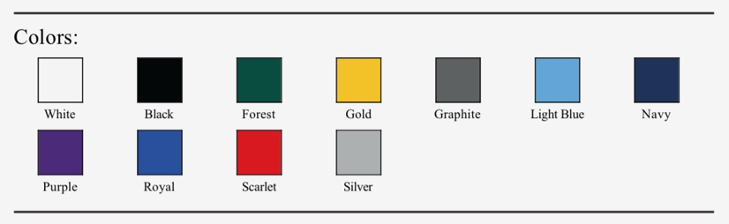

REQUEST COACH / CHILD (Optional)
Child must register in the program, once registration opens for the youth sport. After registration is complete the child will be placed on the sponsored team.

Soccer:
- Name of coach & contact information:

- Name of employee child to place on the sponsored team:

Basketball:
- Name of coach & contact information:

- Name of employee child to place on the sponsored team:

Volleyball:
- Name of coach & contact information:

- Name of employee child to place on the sponsored team:

PAYMENT
Youth Sports Sponsorships will receive an invoice prior to the season. Payments may be made by credit card or check.

*Checks can be made out to the City of Casa Grande, and you can mail or drop the check off at:
Community Recreation Center, 1905 N Peart Road, Casa Grande, AZ 85122

